# Data Preparation

For the clustering analysis our initial aim was to find as much transport data as we could at the MSOA level, since this is the lowest UK geographic level for which relevant transport data could be found. The data collected is shown in figure X below.

|  |  |  |  |
| --- | --- | --- | --- |
| **No.** | **Dataset** | **Description** | **Source** |
| 1 | Public Transport stops | The Geographical Location of all Bus, Tube and Railway stop in the UK | Data.gov (DfT 2014) |
| 2 | Car Ownership | Number of households owning 0, 1, 2, 3 and 4 or more cars in each MSOA | Nomis official labour market statistics (nomis 2013), from 2011 census |
| 3 | Commuter Flow Data | The number of people commuting between all MSOA pairs, disaggregated by mode of travel | 2011 census (nomis 2011) |
| 4 | Travel Time Data | Travel time between all MSOA pairs using bus, rail, and car | Quant Project, CASA (Batty and Milton 2019) |

The 1st dataset contained latitude and longitude values for all transport stops in the UK. To obtain the number of different stops within each MSOA this was merged with a shapefile of the UK MSOAs and a points-in-polygon analysis was performed, as can be seen in figure X. The results from this were then outputted to another csv.

Figure 1 ­- Showing the points of all a) bus stops, b) tram/metro and underground stations and c) all train stations across England and Wales

The 3rd dataset contains travel to work data from one MSOA to another in the form of Origin – Destination pairs for each travel mode, as shown in Fig X.

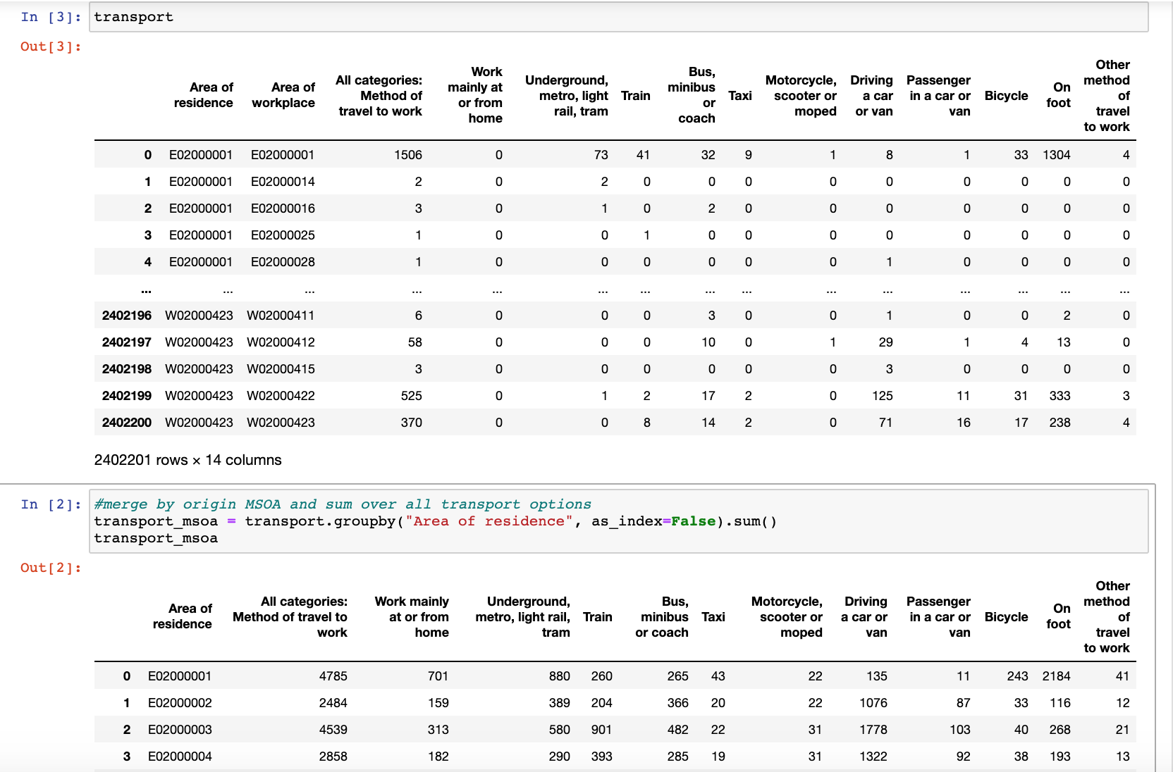

Figure 2: Commuter Flow Data from 2011 Census (MSOA level)

This data was grouped by area of residence and the sum for each transport mode was calculated (fig X). These sums were then turned into percentages of overall travel from MSOA to allow for comparisons. This data was also uploaded to Mysql for the API to map the flows between MSOAs on the website.



Figure 2: Commuter Flow Data Grouped by Area of Residence

The 4th dataset was used to compare [1] the relative accessibility and [2] actual commuting patterns of the different MSOAs.

1. For each MSOA, we calculated the average travel time to all other MSOAs by mode. For example:
2. We join the commuter flow data with the travel time data to get the actual average travel time by mode of the trips originating at each MSOA.

The variables in figure X were subsequently obtained for each MSOA and merged into one dataset (all_transport_data.csv) so that we could conduct the cluster analysis.

|  |  |
| --- | --- |
| Variable (MSOA level) | Description |
| Bus_stops | No. of Bus stops |
| Train_stations | No. of train stations |
| Metro_station | No. of tube stations |
| HH_owning_cars_perc | The % of households owning at least 1 car |
| work_from_home_perc | % of MSOA residents who work from home |
| underground_metro_perc | % of MSOA residents who use each of these modes for their commute (the mode assigned to a person is the one that makes up the largest portion of the trip) |
| car_perc |
| train_perc |
| bus_perc |
| taxi_perc |
| motorcycle_perc |
| bicycle_perc |
| on_foot_perc |
| other_perc |
| avg_time_from_origin_car_UNWEIGHTED | Calculated using Equation (X) |
| avg_time_from_origin_bus_UNWEIGHTED |
| avg_time_from_origin_rail_UNWEIGHTED |
| avg_time_car | Calculated using Equation (Y) |
| avg_time_bus |
| avg_time_rail |

# Data Transformation & Standardization

Before clustering could be performed on the data it is noted the algorithms used, of K-Means, DBSCAN and Hierarchical clustering, are sensitive to inputs that have different units, scales and variations. Therefore, the data must be cleaned, transformed and standardized. For this, we considered the methodology used by the Office for National Statistics to classify output areas (Office for National Statistics 2015), which included transforming and standardizing the variables prior to clustering. A variation of our work is that we apply three different clustering algorithms, whereas the ONS only apply one, because each method produces slightly different outcomes depending on the data. We therefore compare different transformation, standardization and clustering combinations using visual inspection and variable distribution to choose the combination that best represents reality.

## Transformation

Initial exploration of the variable distribution showed that many of the variables were skewed to some degree (Figure X). Using skewed data in clustering analysis is likely to results in clusters that are not reflective of the underlying groups of data because extremes and outliers will likely influence cluster formation, especially for those using distance based metrics such K-Means (Kumar, et al., 2015). Therefore, the data is transformed prior to standardization. Since each variable is not skewed to the same degree, or necessarily in the same direction, two different transformations were applied to the data for which the outcomes and results could be compared. This includes Log and Yeo Johnson transformations to obtain more normally distributed variables, with Yeo Johnson replacing the Box-Cox transformation as the latter cannot handle zeros (Yeo and Johnson 2000). The results of these can be seen in figures X and X below.

Original Variable Distributions

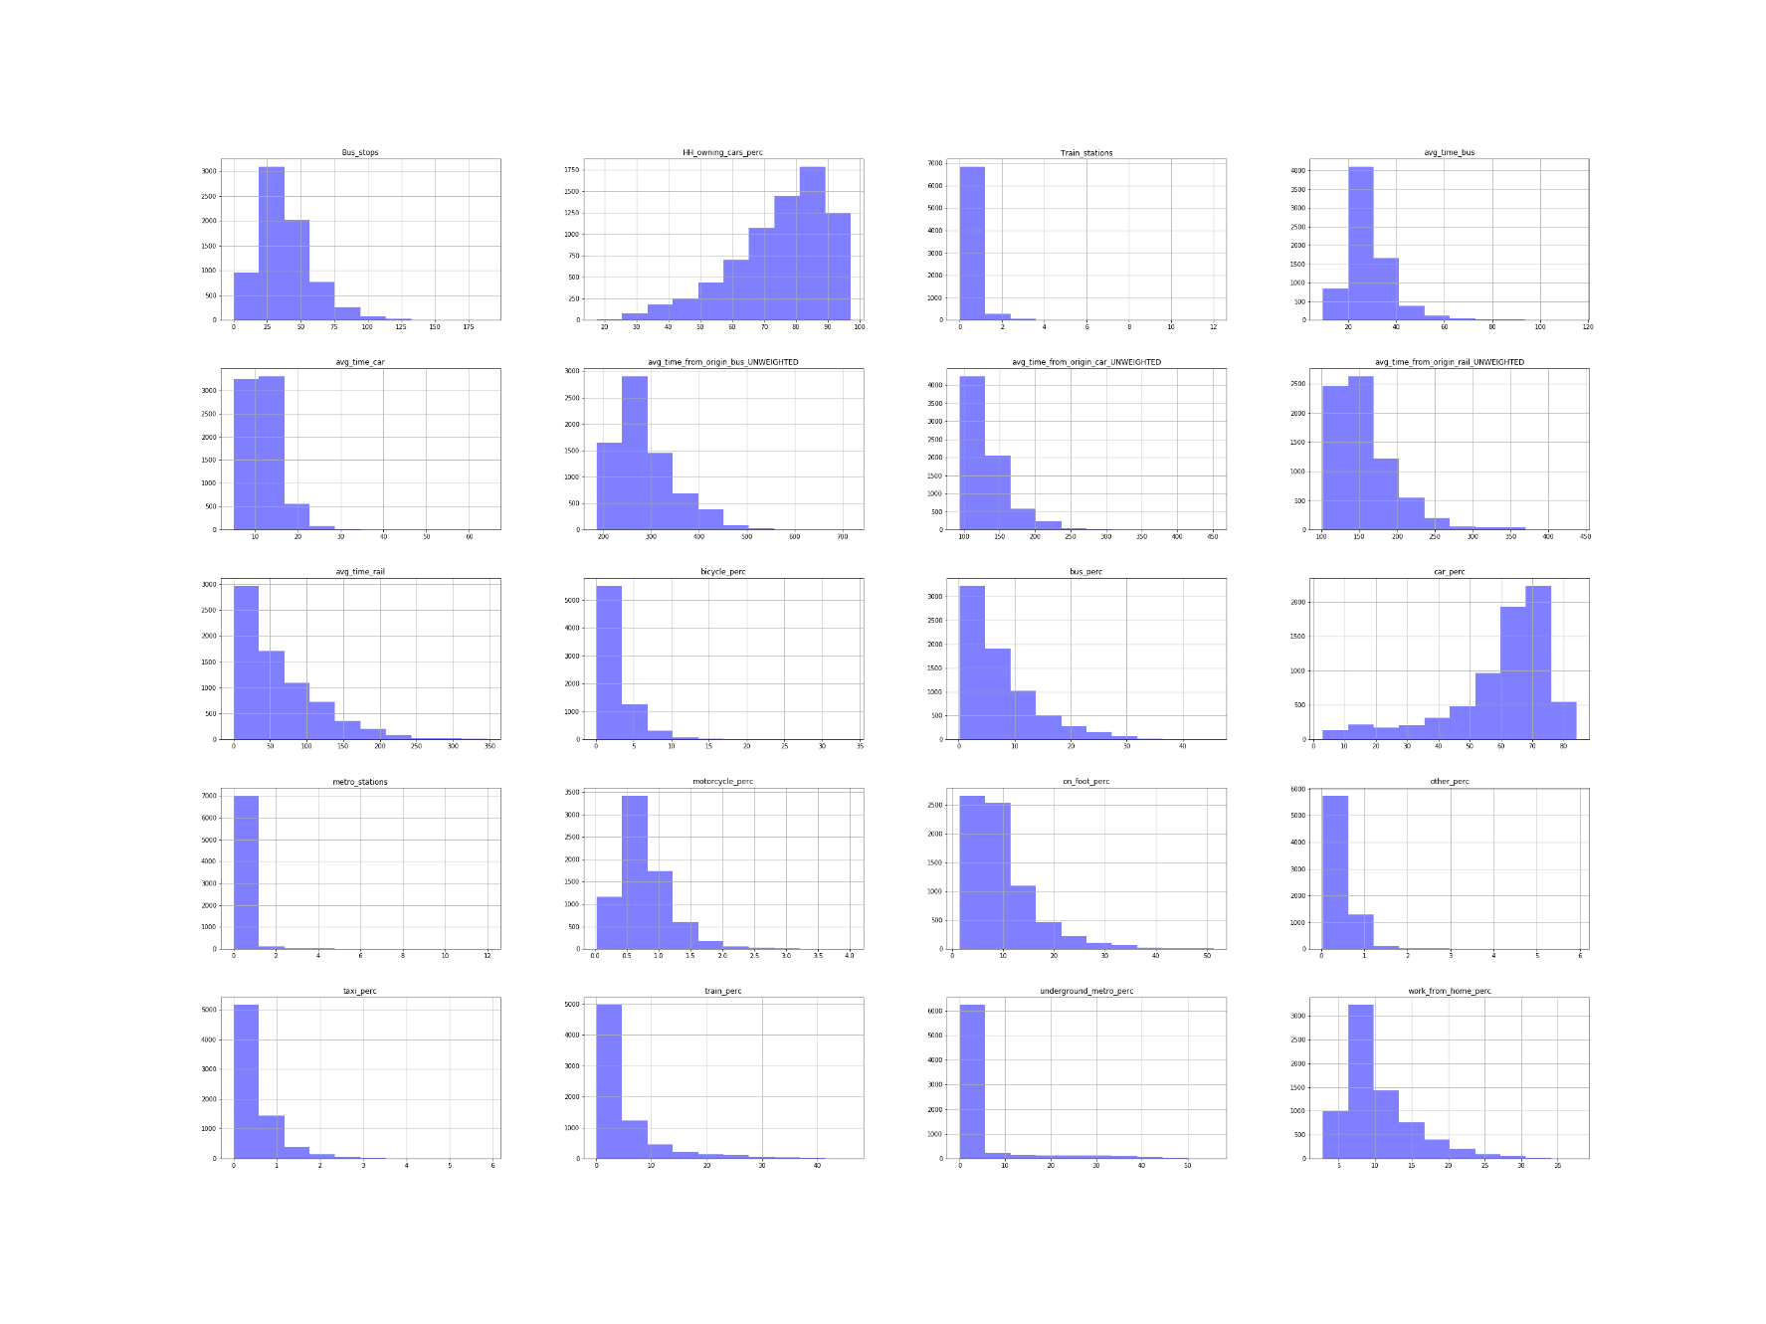

Figure 3: Original variable distributions

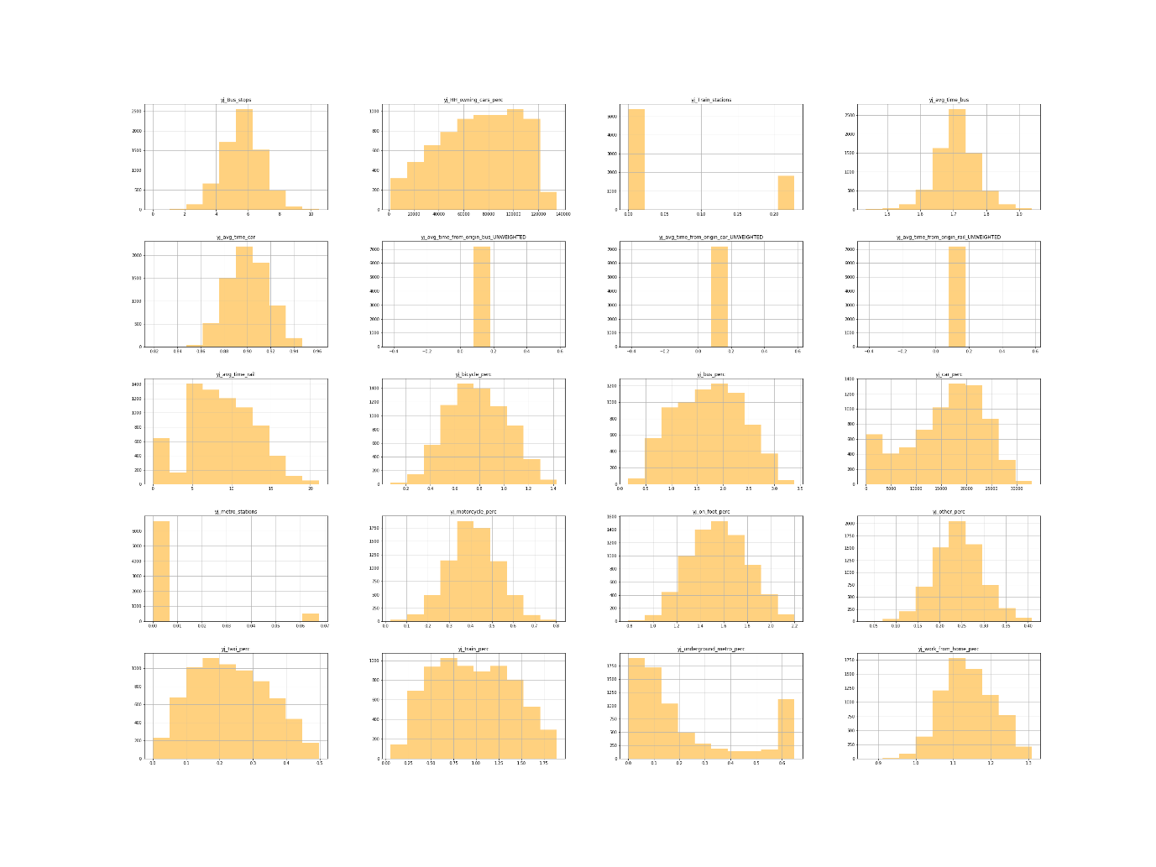

Figure 2: Variable distributions after Yeo-Johnson transformation

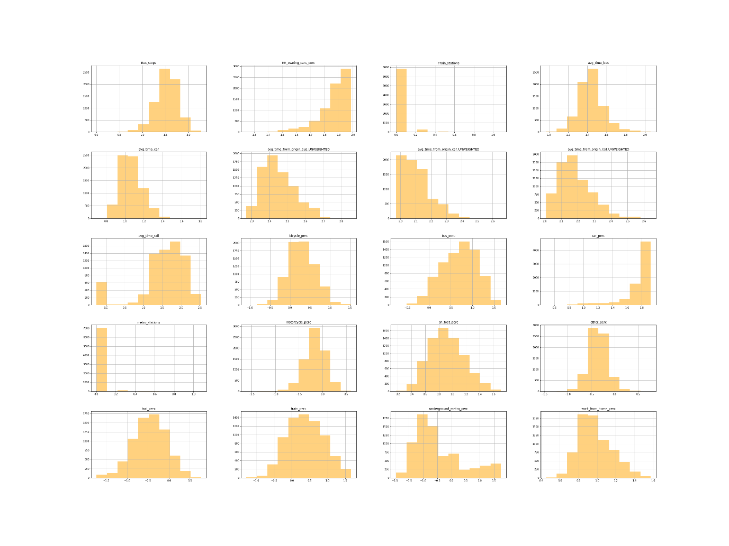

Figure 3: Variable distribution after log transformation

## Standardization

There were differences in units and ranges for each of the variables because it was not possible for all values to be changed to percentages, for example travel time. This is an issue with clustering since variables with the largest size or variability have the biggest influence on the clustering algorithm, especially k-means (Bin Mohamad and Usman 2013). Data standardization is therefore carried out to adjust the relative weight of the variables to avoid this issue (Milligan and Cooper 1988).

The standardization technique used depends on the distribution of the data but since there was no consistent distribution of variables in either transformation, we carried out three different standardization techniques. This allowed us to compare the cluster outputs resulting from different transformation and standardization combinations. The following standardization techniques were used:

### **z-score:**

The resulting values show how many standard deviations each value is from the mean.

### **Range**:

All variables are standardized to have values between 0 and 1.

### **Inter-decile range (IDR):**

IDR standardization is more suited to data with extreme outliers than range standardization as it uses the 10th and 90th percentile instead of the maximum and minimum values.

# Data Analysis

## Clustering

We use three different clustering algorithms and compare the results:

### k-means

### hierarchical (agglomerative)

### DBSCAN

These algorithms differ in their underlying assumptions and the way they perform the analysis, producing slightly different results. Both *k-means* and *hierarchical clustering* require the number of clusters to be specified. Therefore, the optimal number of clusters was found using elbow plots and silhouette scores after multiple runs of each cluster value. Elbow plots are based on minimizing the Within-Cluster Sum of Squares (WSS). The higher the number of clusters the lower the WSS, as the variation becomes 0 when the number of clusters is equal to the number of points. The elbow method ensures that we do not overfit to the data by choosing a number of clusters after which the improvement is marginal.

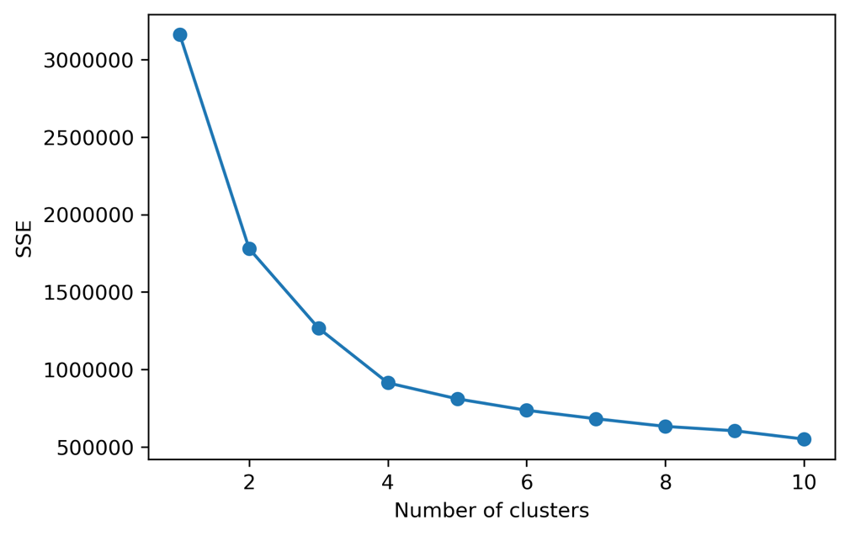

Figure X: elbow plot for log-idr-kmeans

Silhouette scores give us an indication of how compact and separated from each other the clusters are (Chen et al. 2002). The closer points in a cluster are to each and the further away they are from points in the nearest cluster, the better the silhouette score. The two methods measure different things and so did not always give the same results. We therefore used them both for guidance and selected the number of clusters that provided the best results.

DBSCAN is a density-based clustering algorithm where clusters are formed if a minimum number of points are within a given distance (ε) of each other. Unlike, k-means and hierarchal clustering DBSCAN highlights outliers which it does not add to the clusters. The issue with this is that it does not perform well on high-dimensional data and when there are clusters of different densities, as ε cannot be calibrated to suit different clusters.

Consequently, we used 2 transformation techniques, 3 standardization techniques and 3 clustering techniques, resulting in 18 combinations of results. We analyzed each of the results firstly by checking the histograms to see the distribution of MSOAs to clusters in each of the 18 results. For example, DBSCAN created multiple clusters but assigned most MSOAs one cluster and the rest identified as outliers. This can be attributed to the ‘curse of dimensionality’, where the distance between different pairs of points decreases as the number of dimensions increases, and the different density of points (Steinbach, Ertöz, and Kumar 2004).

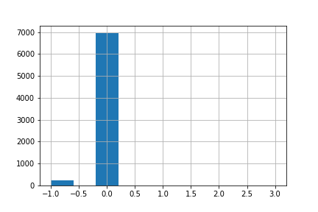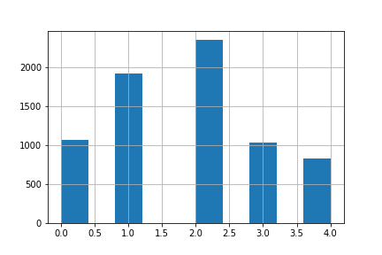

Figure X: Histograms showing Number of MSOAs assigned to each cluster. LEFT (log_range_DBSCAN) &) RIGHT (log_range_kmeans)

K-means and Hierarchal clustering algorithms on the other hand provided clearer and more consistent results, which were compared by looking at the variable distribution and maps of the clustering results.

## Variable Selection

To improve interpretability and clarity of results, variables that did not influence the results were removed. This included variables that were highly correlated (i.e. motorcycle percentage). Therefore, we removed variables in sequence to see what affect, if any, they had on the clustering results. The first step was to remove other and taxi (commuter mode shares). The results appeared to be unaffected and had improved interpretability. Then the number of bus stops, train stations, and metro stations were further subsequently removed as even though they appear intuitively to be of importance they could not be clearly interpreted and did not influence the clustering results. This could have potentially been due to the difference in geographic size of MSOAs. Consequently, we ended up with 14 variables in the final clustering results.

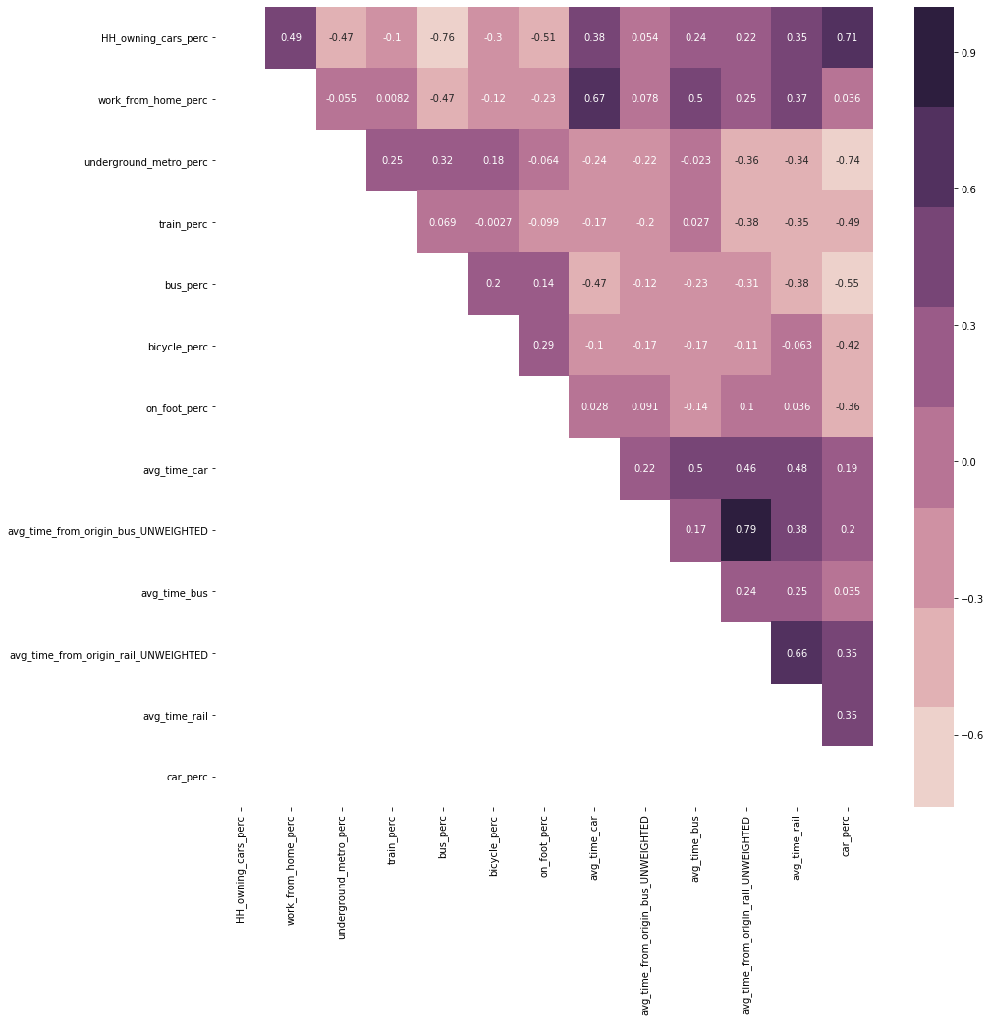

Figure X: Correlation of variables used to produce clustering results

## Comparing Results

Once 14 variables were chosen, the steps above were repeated. The result we decided that best represented differentiation in clusters and mapped onto our knowledge of existing geography in the UK was the:

log (transformation) -> z-score (standardization) -> kmeans (clustering)

The resulting output was 5 clusters with distinct combinations of variable characteristics, as can be seen from the variable averages in each cluster (Figure X) with descriptions of each cluster given in table X.

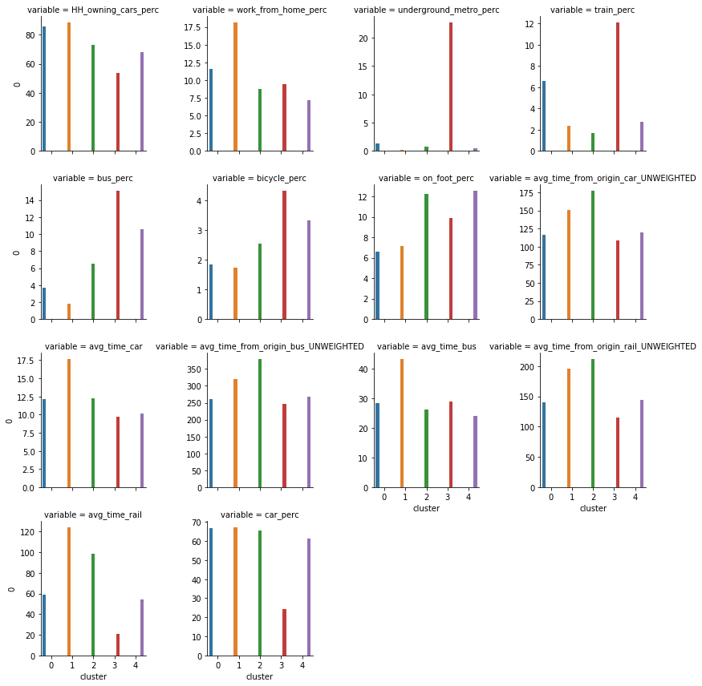

Figure X: Variable averages in each cluster

Table X: Cluster Descriptions

|  |  |  |
| --- | --- | --- |
| ***Cluster*** | ***Plot Colour*** | ***Extended Description*** |
| 1 | Blue | **Good train accessibility but car dependant**: The cluster is composed of rural areas that surround land-locked urban areas. They are mainly in the center of the UK, compared to rural areas in cluster 2 which are on the outskirts. This central location is reflected in their relatively better accessibility scores across all transport modes with the second best accessibility scores for these. The clusters benefit from being on train routes with the second highest train usage but that is the only mode of public transport that they are serviced by. As a result, the cluster is associated with high car ownership and usage, followed by train and walking. |
| 2 | Yellow | **Solely car dependant**: The cluster is made up of rural areas far from the cities. They have no public transport options and people depend on cars to move around. They have poor accessibility even by car, and this could be due to a lack of direct road connections between them and other parts of the country. The cluster is found on the periphery of cluster 2, which is itself made up of coastal cities (like Newcasle and Cornwall) with poor accessibility |
| 3 | Green | **Lack of accessibility across all Transport modes -** This cluster shows the third highest usage of bus, bicycle and walking to work, but has the lowest train usage, working from home and all around accessibility. The most popular modes to travel to work are by car, by walking and bus but the lack of accessibility across all modes and little train usage is the defining feature. This can be found in coastal towns and cities such as Newcastle, Cardiff and Blackpool which might suggest they are at the end of train lines and other transport networks and therefore lack connectivity apart from internal bus usage. |
| 4 | Red | **High public transport and good accessibility** - The cluster is associated with high usage of public transport including the underground/metro/tram, train and bus. It is noted to have very good accessibility to all MSOAs through all transport modes therefore highlighting the ability of people to easily move around. This cluster dominates London, but can also be found in the centre of some MSOAs in big cities like Manchester and Birmingham. The cluster suggests that the transport profile of London is different to the rest of the UK and can only otherwise be found in high accessibility centres of large cities. |
| 5 | Purple | **Car reliant but high public transport** - This cluster has high car usage but is notable for the large number of people who use the bus and walk to work. These MSOAs also have a high degree of accessibility but the overall transport profile is more shifted towards cars than the previous cluster. This is found in large Urban areas across the UK such as Manchester and Birmingham, suggesting that the main differnece between these and London is the degree of usage of public transport with the main difference occuring due to the lack of usage of an underground/metro/tram. |

## Classification

Our aim was to not only to create different transport profiles but to understand the demographic factors related to these results, therefore the next step was to run a classification analysis. For example, previous research i.e. (Titheridge, et al., 2008), (Pinjari, et al., 2007), (Ferdous, et al., 2011) suggests that demographic characteristic such as income, unemployment, education level and sex can influence transport travel mode choice. Therefore, based on available data at the MSOA level, the following variables (Table X) were chosen to understand how they are related to the transport profile groups.

Table X: Variables used in Classification

|  |  |  |
| --- | --- | --- |
| **Dataset** | **Description** | **Source** |
| Net annual income (£) | Average net annual income in 2018 | Office for National Statistics (ONS 2020) |
| Pop_Per_Hectare | Population density | Office for National Statistics (ONS 2019) |
| percent_unemployed |  | 2011 Census (nomis 2011) |
| percent_at_or_above_qual_  level_4 | The % of people living in the MSOA that achieved Qualification Level 4 or above |
| perc_households_owned | The % of households in the MSOA that are owned |
| avg_number_of_bedrooms |  |
| perc_bad_health | The % of residents who suffer from bad or very bad health |
| perc_employed_females_  working_fulltime | The % of the labor force that is made up of employed females working >35 hours per week |
| mean_age |  |
| perc_christian |  |
| perc_non_religious |  |

A Random Forest classification with 100 trees, with max depth set to 3 to aid interpretability of results, was ran. Oshiro, Perez, and Baranauskas (2012) note that beyond a certain threshold of trees, there is no improvement in model performance, and suggest a value between 64 and 128.

### Results

The results produce an overall score as result of many trees.

Table X: Random Forest Results

|  |  |  |  |
| --- | --- | --- | --- |
|  | precision | recall | f1-score |
| 0 | 0.83 | 0.52 | 0.64 |
| 1 | 0.59 | 0.07 | 0.12 |
| 2 | 0.77 | 0.76 | 0.76 |
| 3 | 0.60 | 0.81 | 0.69 |
| 4 | 0.62 | 0.81 | 0.70 |
|  |  |  |  |
| accuracy |  |  | 0.65 |
| macro avg | 0.68 | 0.59 | 0.58 |
| weighted avg | 0.66 | 0.65 | 0.60 |

The accuracy score shows that 65% of MSOAs are classified correctly by the model. The precision value shows that the model was prone to false positives, particularly with cluster 1, 3, and 4. The recall score shows that the model was unable to give the correct value for cluster 1, meaning that most MSOAs in cluster 1 were misclassified. The confusion matrix (Figure X) shows that only 19 out of 284 MSOAs in cluster 1 were correctly classified.

Figure 4: Confusion Matrix for Random Forest Classification

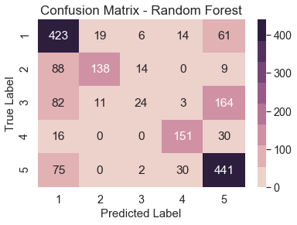

### Feature Importance

To understand which variables were most related to transport characteristics, we use feature importance. The default feature importance, based on gini impurity, is biased, especially when variables vary in scale; continuous and high cardinality variables (variables with many unique values) tend to rank higher even if they are no more informative than other variables (Strobl et al. 2007). Therefore permutation importance was used (Altmann et al. 2010), as it is less biased in its interpretation of feature importance than the default sklearn feature importance.

The importance is based on calculated the coefficient of determination (R2), randomly reshuffling one variable, then recalculating R2. The decrease in model performance (difference in R2) is a measure of the variable’s importance.

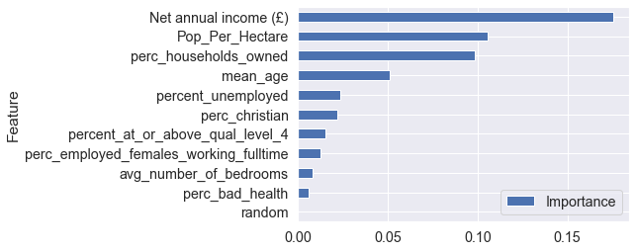

Figure : Permutation Importance for variables used in classification

We added a random variable to the model to see if any variable performed worse than it, but none did. Population density is the most important feature which is not surprising given that public transport is mostly associated with urban agglomerations. Religious variables and unemployment rate have little predictive power, indicating that they may show uniform distribution across the study area.

### Splitting

We can attempt to understand how the model has been trained by looking at individual trees such as in figure X. Here, cluster 4 associated with high public transport usage is suggested to have an income above £33,850 and the percentage of households owned is greater than 59.25%. While in contrast, cluster 1 with good train accessibility but still car dependent is associated with an income below £33,850 and a mean age less than 38.25. Furthermore, looking at class 2 and 5, although they are both associated with low income, and a high mean age, cluster 5 is suggested to have a higher population density than cluster 2. From these we can begin to understand how factors may influence transport profile, although it must be acknowledged that the tree shown below is based on a subsample of all data collected (3,449 MSOAs). Therefore, this could be advanced if we had more time by exploring more of the resulting decisions trees and gaining a better understanding of the factors that may influence transport behavior in the UK.

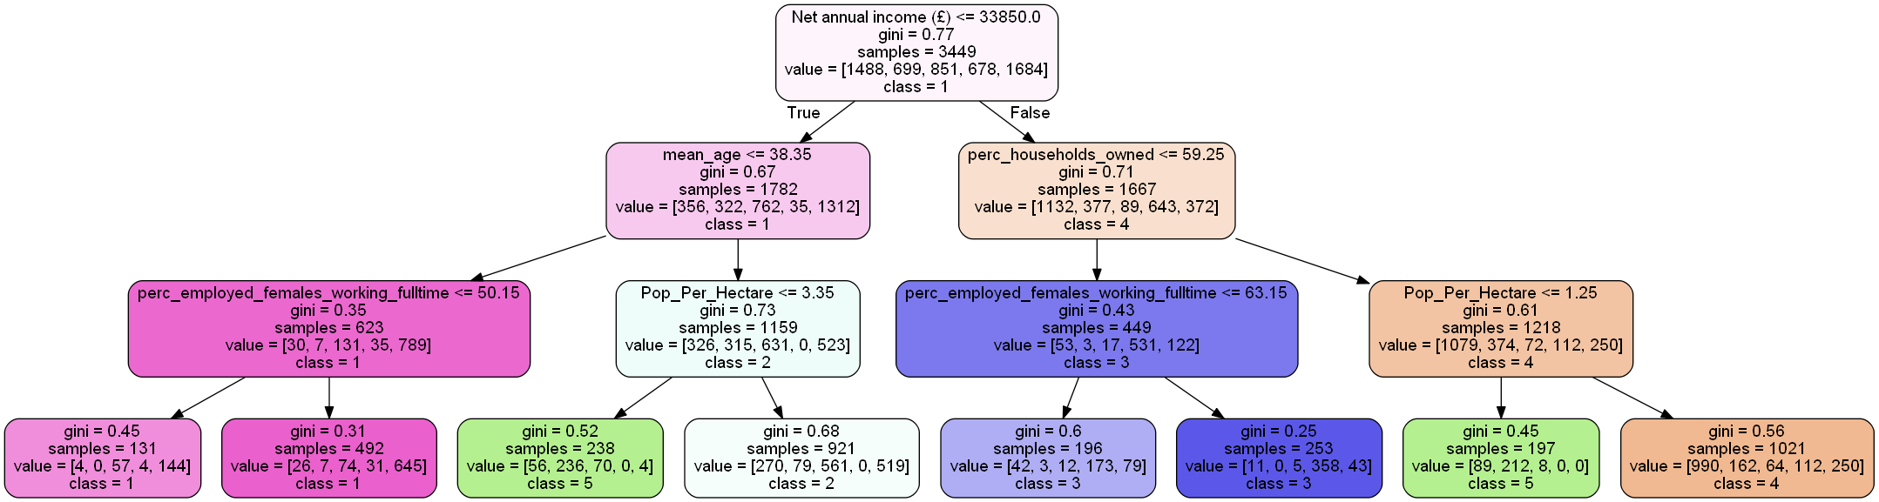

**Word count: 3064**

**Word count with splitting: 2994**

**Word count – tables (don’t count anyway) 2000/2153**

**Table word count = 835**